**Assessing stock structure of Pacific cod (*Gadus macrocephalus*) by combining ecological and evolutionary perspectives**

**Abstract**

Inclusion of population structure in marine fisheries management protects local populations from overexploitation, and allows for a more sustainable yield. Population structure is often assessed from a genetic perspective, which offers insight

However, the actual distribution and migration of individuals which contribute to these evolutionary patterns is often unclear, and can be important for fisheries managers who work primarily on ecological timescales.

**INTRODUCTION**

The purpose of this study was to explore Pacific cod spawning population structure and site fidelity around the Korean peninsula according to otolith microchemistry, and to then compare these results from otolith microchemistry with genetic population structure. In doing so, we address three key questions:

1. How different are otolith microchemical concentrations across Pacific cod spawning grounds around the Korean peninsula?
2. Did Pacific cod return to their natal spawning ground during the spawning season in which they were caught?
3. Does the genetic population structure that developed over evolutionary timescales align with spatial spawning patterns and site fidelity determined from individual life histories?

**METHODS**

*Sample Collection*

A total of 322 fin clips and tissue samples were collected from ten Pacific cod spawning aggregates in the coastal waters around the Korean peninsula (Table, Figure). Three aggregates were sampled during the 2007 – 2008 winter spawning season, three aggregates during the 2014-2015 season, and one each during the 2015 – 2016 season. These do not include sample groups taken as temporal replicates, one between-year replicate during the 2013-2014 season, and one within-year replicate during the 2007-2008 season. Fin clips and tissues were preserved in 95-100% non-denatured ethanol, stored at 4C.

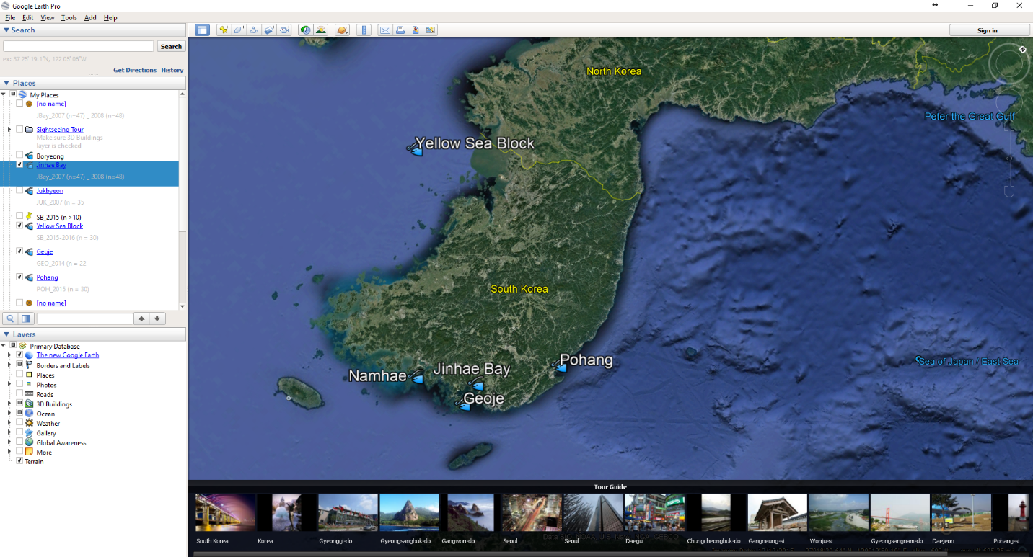

**Figure 1.** Map of sampling locations around the Korean peninsula.

**Table 1.** Number of samples for each sampling site and spawning season *that were used in this study.* Site names correspond to those in **Fig. 1**.

|  |  |  |
| --- | --- | --- |
| **Sampling Site** | **Spawning Season** | **N. Samples** |
| Yellow Sea | 2015-2016 | 18 |
| Namhae | 2014-2015 | 13 |
| Geoje | 2013-2014 | 16 |
| Geoje | 2014-2015 | 30 |
| Jinhae Bay | 2007-2008 (early) | 30 |
| Jinhae Bay | 2007-2008 (late) | 30 |
| Pohang | 2014-2015 | 30 |

*Microchemistry*

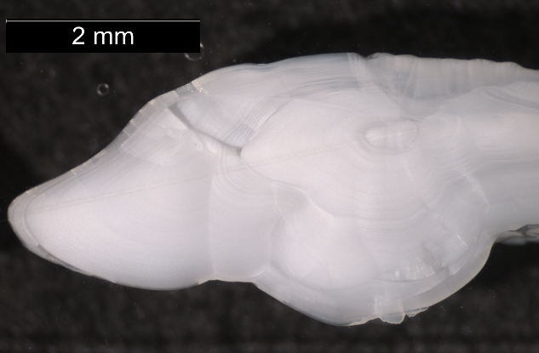

**Figure 2.** Illustration of LA-ICPMS scan line on Pacific cod otolith. Tick marks delineate end of each year of life, used to age the individual.

*RAD sequencing and SNP genotyping*

DNA was extracted from fin clip and tissue samples using DNeasy Blood & Tissue Kits (Qiagen, Inc.). DNA was then quantified using Quant-iT PicoGreen dsDNA Reagent (Invitrogen, Carlsbad, CA) and visualized on an agarose gel. A total of 283 samples were prepared for RAD sequencing according to Baird et al. (2008) and Etter et al. (2011), with modifications to incorporate Agencourt AMPure XP beads (Beckman Coulter, Inc., Pasadena, CA) for purification (Gruenthal et al. in prep). Sequencing of 150bp single end (n = 157) and paired end (n = 126) reads was completed on an Illumina HiSeq 4000 (Illumina, Inc.) at the University of Oregon’s Genomics and Cell Characterization Core Facility.

Quality filtering and demultiplexing of raw RAD sequencing data, as well as de novo construction of a reference database of RAD loci, SNP discovery, and genotyping was completed using a combination of the Stacks 1.44 pipeline (Catchen et al. 2011; Catchen et al. 2013), Bowtie (Langmead et al. 2009), and NCBI’s Basic Local Alignment Search Tool, BLAST (Altschul et al. 1990), according to the procedures outlined in Gruenthal et al. (in prep) and Brieuc et al. (2013). A genotype file containing putative polymorphic SNPs present in ≥ 80% of fish per spawning aggregate was filtered to include one SNP per RAD tag. Final filtering was then used to remove loci with minor allele frequencies (MAFs) with < 0.05 in all spawning aggregates, loci that did not conform to Hardy – Weinberg equilibrium, and loci missing more than 20% of genotypes in any of the spawning aggregates. Individuals were removed from the data set if they were missing more than 30% of loci, or were found to be potentially contaminated.

*Data Subsetting*

After filtering out individuals which were not present in both genetic and otolith microchemical datasets, data were subset to only include individuals two years and older, according to otolith aging methods. Fish less than two years old are considered juveniles, and therefore not spawning fish, which are the subject of this study. Additionally, it is not known whether there is an ontogenetic shift in spawning migration patterns between adult and juvenile fish; thus the inclusion of juvenile fish in these analyses could lead to the mischaracterization of Pacific cod spawning behavior.

The size of the data set was further reduced for computation simplicity and to achieve more even sample sizes. Individuals were randomly removed from both Jinhae Bay 2007-2008 early and late spawning groups, so that the number of samples in each group reached n = 30.

*Analysis of otolith microchemistry data*

Microchemistry data normality using Mardia’s multivariate normality test and QQPlot visualization with the R package MVN (cite). The data did not conform to multivariate normality. Data transformations, including natural log, log10, cube root, and square root transformations, did not normalize the data set. Thus the multivariate analytical methods (below) for this data do not include distributional assumptions.

Visualization of otolith microchemistry data by element and sampling site showed markedly different scales, so each element’s concentration ratios were relativized by maxima using the R package vegan2. A Euclidean distance matrix was then calculated separately for the elemental ratios measured at the core of the otolith, and the elemental ratios measured at the edge of the otolith.

To determine whether elemental fingerprints differed significantly between the sampled Pacific cod spawning grounds, I ran a PERMANOVA on the elemental ratios at the edge of the otolith against a combination variable of sampling site and spawning year, with 100,000 permutations. To further explore differences between sites and years for each individual element, an ANOVA was conducted for elements that conformed, or could be transformed, to the assumed normal distribution. This consisted of four elements: Barium138 (natural log-transformed), Magnesium24 (natural log-transformed), Strontium88, Zinc66 (natural log-transformed). I then ran a non-metric Multi-dimensional Scaling Analysis (NMDS) on elemental ratios from the edge of the otolith, and fit element vectors to the ordination using vegan2, to identify which elements were correlated with the separation of specific sampling sites across the ordination space. Although this step is commonly completed by conducting a Linear Discriminant Analysis3–5, NMDS has been used when data do not conform to multivariate normality6. The NMDS was run with the wrapper function metaMDS in vegan2, with a maximum of 400 iterations and minimum of 40 runs (McCune & Grace 2002). In order to determine the optimum number of dimensions, “k”, I ran the NMDS with 1 through 7 dimensions (the number of sampling units), then evaluated a plot of dimensions against associated stress values. The minimum stress value was achieved with seven dimensions, which was used for the final NMDS.

To approach the question of site fidelity, a Mantel test was used to determine whether there was a correlation between the elemental fingerprint at the otolith core and the otolith edge for each fish, which would indicate similar elemental signatures of the individual’s natal and final spawning ground. I ran the Mantel test using Pearson’s correlation coefficient and 100,000 permutations.

While the Mantel test may suggest correlation between the elemental fingerprint at the core and edge of the otolith…

*Visualization of combination data set*

**RESULTS**

*Microchemistry of Spawning Grounds*

A PERMANOVA of microchemical data by sampling unit (includes site location and year) showed significant differences in elemental fingerprints between sampling units. ANOVAs were conducted on four of the eight elements to explore element-specific differences between sampling units: Barium138, Magnesium24, Strontium88, and Zinc66. All four ANOVAs were highly significant (p values ~ 0), suggesting that the mean concentrations of these elements were significantly different between sampling units.

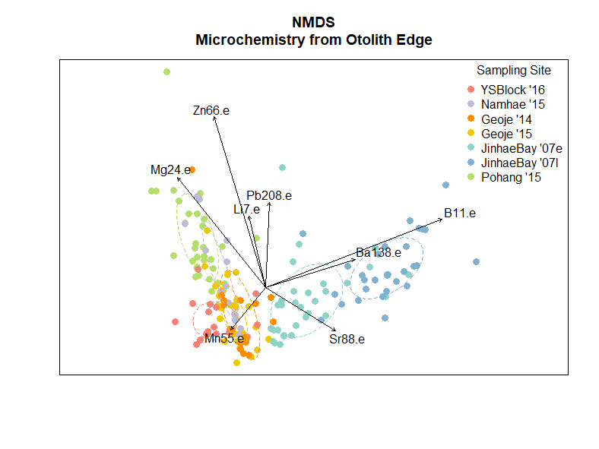A non-metric Multi-dimensional Scaling (NMDS) ordination provided insight into how element concentrations differed between sampling units. The NMDS, run with seven dimensions, produced a stress value of 0.01215, which is associated with excellent representation of the data set (Clarke 1993), and a linear fit of R2=0.999. The ordination showed distinct separation between the Jinhae Bay sampling site (both early and late in the 2007-2008 spawning season) and the remainder of the data set (**Fig. 1**). Vectors indicating the fit of elements along the ordination axes suggest that boron (B11), barium (Ba138), and strontium (Sr88) concentrations lead to the differentiation of this site. Samples from Pohang (2014-2015 spawning season) also appear to differentiate across the ordination space; this differentiation is strongly correlated with magnesium (Mg24) and zinc (Zn66) concentrations, and somewhat correlated with Lithium (Li7) and lead (Pb208).

**Figure 1.** Non-metric Multidimensional Scaling ordination of all samples. Ellipses show standard deviation around the centroid of each cluster. Vectors display correlation between specific element loadings and ordination axes.

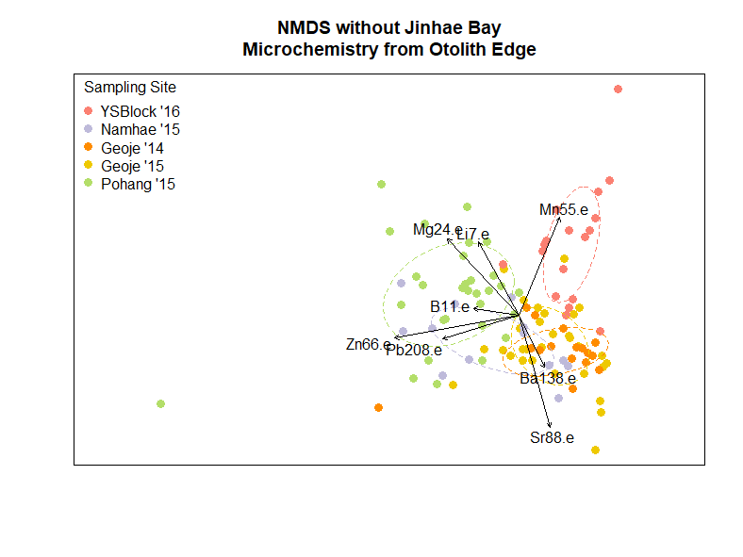To see if differentiation of the remaining groups would be more evident without the highly differentiated Jinhae Bay samples, I re-ran the NMDS excluding Jinhae Bay. I used the same parameters and evaluated the appropriate number of dimensions in the same manner as with the NMDS for the full data set. The resulting NMDS of five dimensions had a stress of 0.0464 (**Fig. 2**). By excluding Jinhae Bay, the separation of Pohang from other samples became more evident. Additionally, the samples from the Yellow Sea sampling site (2015-2016 spawning season) differentiated along the second axis, primarily as a result of manganese (Mn55) concentration.

**Figure 2.** Non-metric Multidimensional Scaling ordination excluding Jinhae Bay samples. Ellipses show standard deviation around the centroid of each cluster. Vectors display correlation between specific element loadings and ordination axes.

Both Geoje and Namhae sampling sites remained clustered together in the ordination space, although they differentiate slightly from the Yellow Sea and Pohang sites due to barium (Ba138) and strontium (Sr88) loadings.

Together, these ordinations suggest that the Jinhae Bay, Yellow Sea and Pohang sites can be differentiated from each other and the remaining samples as a result of specific element combinations.

*Site Fidelity*

A Mantel test between distance matrices calculated from otolith core concentrations and otolith edge concentrations suggested slight positive correlation (p = 1 x 10-5, r = 0.3372) between full elemental fingerprints of each individual’s natal spawning ground and the spawning ground at which they were caught.

A cluster analysis with